Located in the middle of the magnificent red rocks of Southern Utah, Zion National Park is home to some of the most unique and breathtaking sights in the world. Hikes, like Angels Landing, The Subway, Kolob Arch, and the Narrows (to name a few), create a recipe for a one-of-a-kind national park that attract millions of visitors every year. Although the beautiful landscapes surrounding the park have been around for tens of thousands of years, Zion National Park will officially turn just 100 years old in November 2019. So, when did Zion get to be such a popular location for tourists from all over the globe?

# Visitor History by the Numbers

On November 20, 1919, President Woodrow Wilson signed a Congressional bill that officially designated this area as a national park. That inaugural year, the park counted 1,814 visitors to the park. The following year, that number was nearly doubled with 3,692 visitors. The park saw a steady increase in visitors from year to year until the U.S. entered World War II at the end of 1941, when park visitation dropped significantly. After the war ended, park visitation continued right where it left off before the war. Since then, visitation at the park has increased at an almost exponential rate as it reached its first 1 million visitor count in 1975. It took just an additional 15 years to reach 2 million visitors, but it wasn’t until 24 years later that the park reached 3 million visitors in one calendar year.

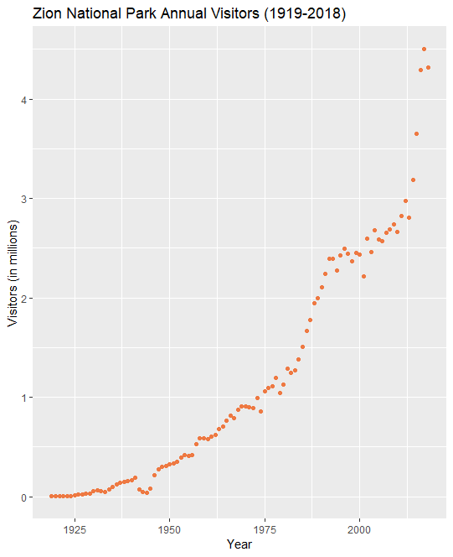

Data from irma.nps.gov

The most significant increase in visitors has come during the last five years. The year 2014 saw nearly 3.2 million visitors, then quickly hit the 4 million mark two years later in 2016. The most visitors in a year to visit Zion National Park was 2017 when it saw about 4.5 million visitors.

# No Slowing Down

Although visitation dropped over 100,000 visitors in 2018, don’t expect that to be the trend in the next five years. Forecasts show that the number of visitors to Zion National Park is only expected to climb higher and higher as it grows in both recognition and popularity around the world.

|  |  |  |
| --- | --- | --- |
| Zion National Park Visitation 5-Year Forecast  (in millions) | | |
| Year | Estimate | 95% Confidence Interval  (lower, upper) |
| 2019 | 4.5 | (4.0, 5.2) |
| 2020 | 4.7 | (4.0, 5.6) |
| 2021 | 4.9 | (4.0, 6.0) |
| 2022 | 5.1 | (4.0, 6.5) |
| 2023 | 5.3 | (4.1, 6.9) |
| A time series forecast was used in the analysis to get these figures | | |

Zion National Park can expect to hit the 5 million visitor mark sometime around 2022, barring some unforeseen events (i.e. government shutdowns, inclement weather, landslides, etc.) that would cause a sudden decline in the number of visitors.

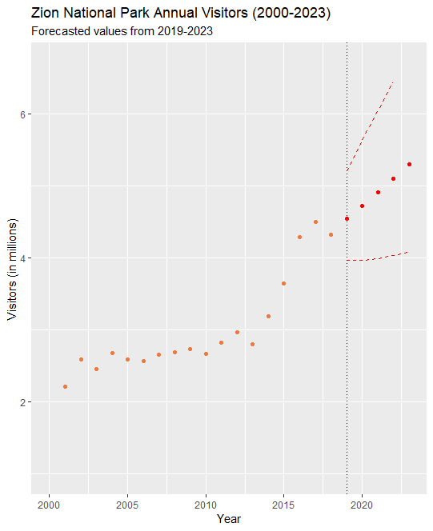

# Why Does it Matter?

This “100-year flood” of visitors will leave its mark on Zion National Park. Over 120 million people have visited Zion National Park since its official opening 100 years ago. Almost half of the 120 million visitors are from just the last 25 years! As the numbers of visitors continues to climb, the park laborers will struggle to keep up. More people visiting will result in more resources being used and more wear and tear to the trails. In the coming years, the park could see some frequent or extended closures for some of the more popular hikes in order to make repairs and improvements as a result of the heavy traffic.

If you’re planning a visit to Zion National Park sometime soon, beware of crowded trails and long lines at shuttles during your stay. If you want to avoid the crowds and still enjoy a memorable outdoor experience, consider visiting some of the smaller state parks Southern Utah has to offer and which also have unique and majestic characteristics of their own.